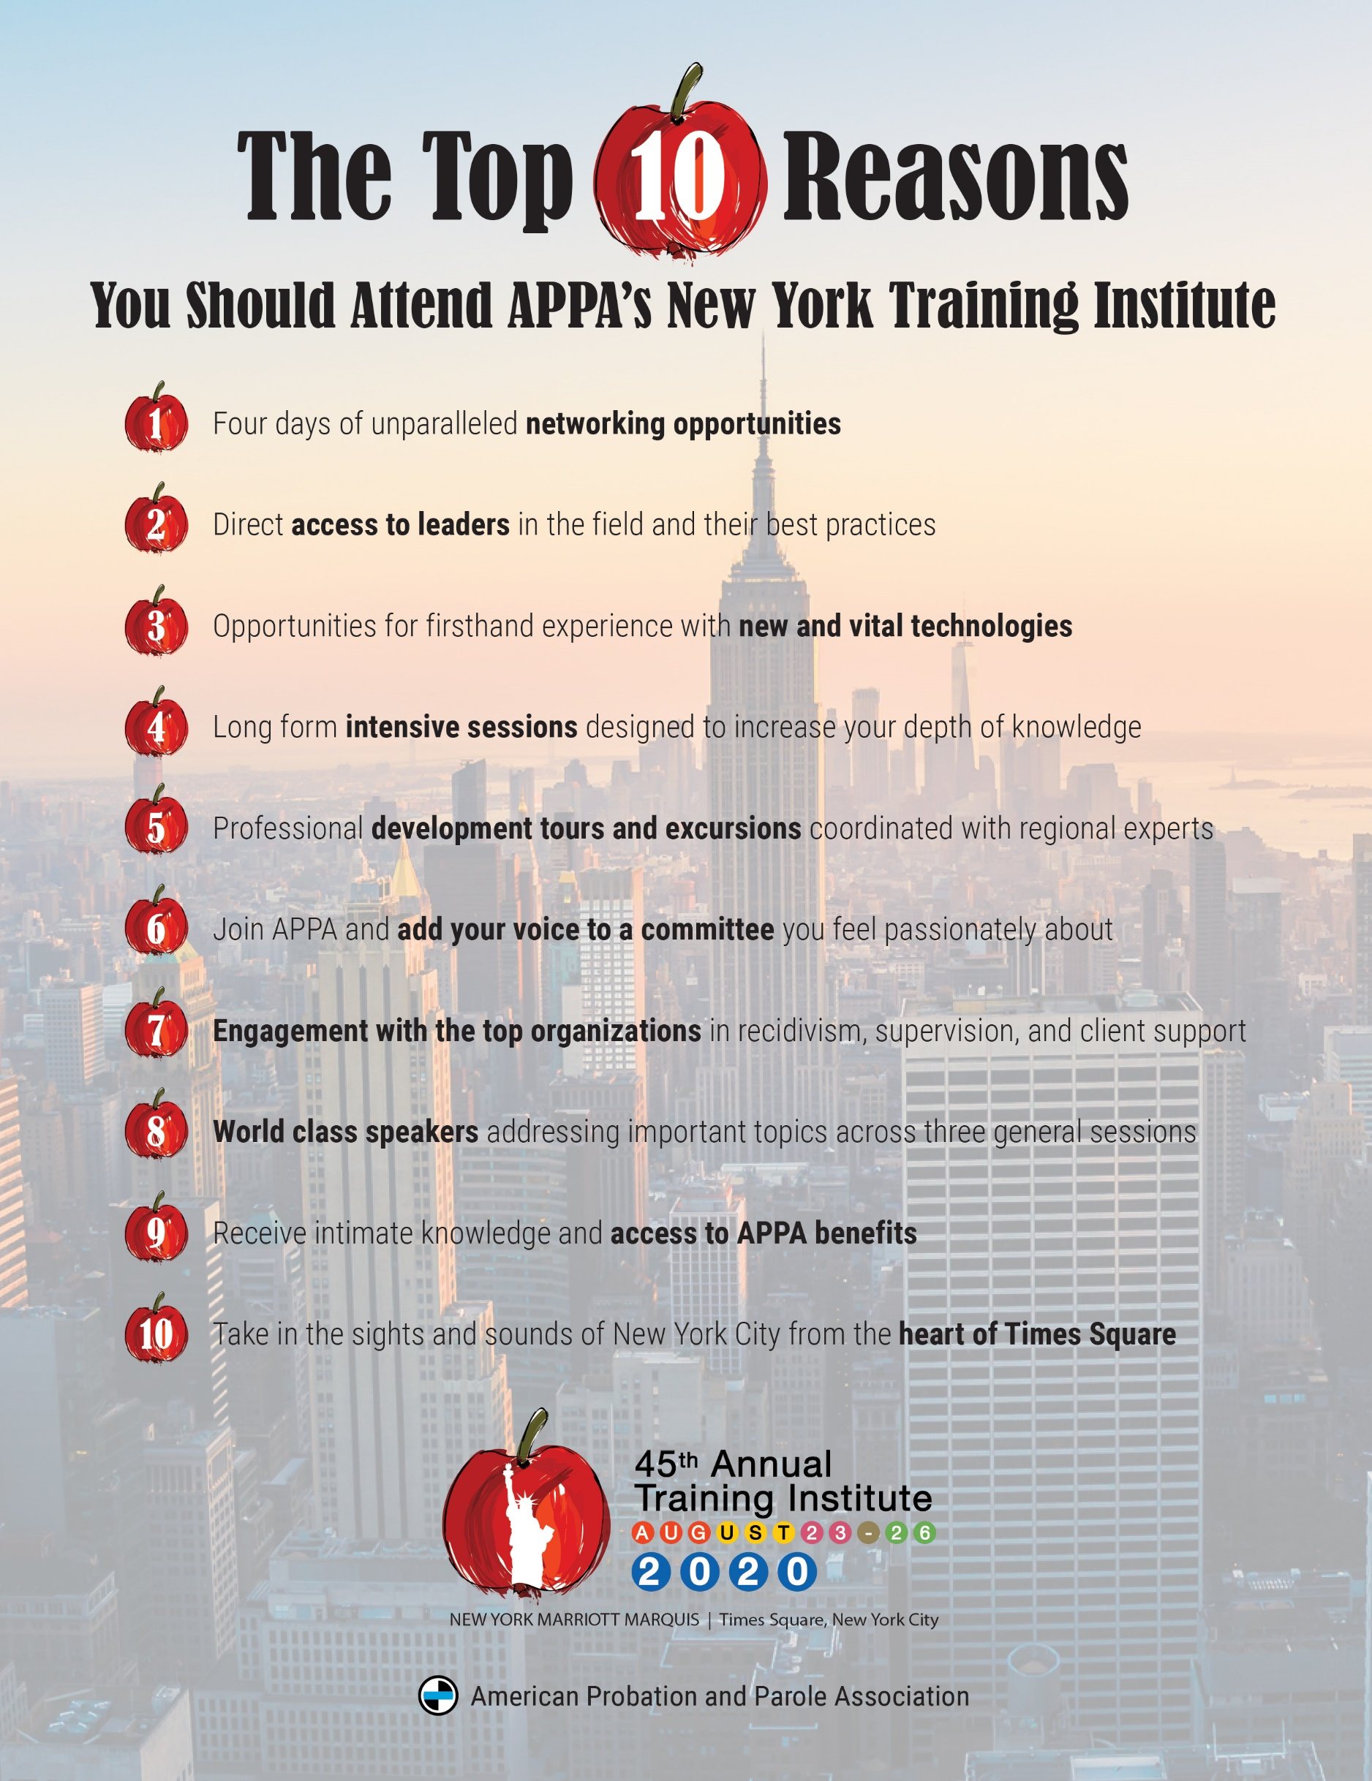

< Date >

Dear < Manager >,

I’d like to request permission and funding to attend the American Probation and Parole Association’s (APPA) Annual Training Institute from August 23-26, 2020 in New York City. As you know, APPA is the leading professional membership association for those in the community corrections field. Their bi-annual training institutes offer a unique opportunity to attend numerous educational sessions, assess available resources, and network with other leaders in the industry.

With three general sessions and more than 80 breakout sessions, I’ve identified numerous workshops which make this year’s training institute vital to my work as a community correction professional. The training institute’s offerings will address many of the issues we face while providing ideas and information to help me stay ahead of the challenging work done in this environment. Upon my return to the office, I will share best practices, contacts, resources, tools, and trends with you and my co-workers.

To help with your decision, here is the cost breakdown through July 10th for me to attend the training:
Registration: $ 400/individual member; $405/agency member; $520/non-member
Hotel, Standard Room: $ 228/night + taxes/fees (Government Per Diem)
Airfare (RT): $xxxx
Per Diem: $71 per day
TOTAL $

With such great educational content, having representatives from < Your Agency Name > at this training will allow our team to gain valuable insight and information that will help us create lasting change in our community corrections world. You can find more information about the Annual Training Institute by visiting APPA’s website, appa-net.org.

Thank you for your thoughtful consideration of my request.

Sincerely,

< Your Name Here >

